College of Saint Benedict & Saint John’s University

Computer Science Department

eSaint Auction System (eSAS)

Phase 1: Analysis and Specification

Team Name: Rahal Rampager

Team Member: Justin S., Katherine K., Philip N., and Tsuehue X.

Date: 9.4.2013

**Table of Content**

Website Map Diagram..……………….……………………………………………………………………………………………..………...3

UI Diagrams……………………………………………………………………………………………………………………………………………4

Add Item……………………………………………………………………………………………………………………….4  
Admin Management Page……………………………………………………………………………………………4  
Bid Management…………………………………………………………………………………………………………4  
Bid On Item………………………………………………………………………………………………………………….4  
Bidder List……………………………………………………………………………………………………………………5  
Check Status………………………………………………………………………………………………………………..5  
Feedback……………………………………………………………………………………………………………………..5  
Item Info……………………………………………………………………………………………………………………..6  
Item Profile………………………………………………………………………………………………………………….6  
Item Search………………………………………………………………………………………………………………….6  
List Items Sold……………………………………………………………………………………………………………..6  
List of Items Bid On……………………………………………………………………………………………………..7  
Login Page…………………………………………………………………………………………………………………..7  
Overall Commission Report…………………………………………………………………………………………7  
Profile Page…………………………………………………………………………………………………………………8  
Profile………………………………………………………………………………………………………………………….8  
Rate as Buyer………………………………………………………………………………………………………………8  
Reports………………………………………………………………………………………………………………………..9  
Sales Summary Report…………………………………………………………………………………………………9  
Search Results………………………………………………………………………………………………………………9  
Selling Management Page……………………………………………………………………………………………9  
Update Profile……………………………………………………………………………………………………………..10  
User List……………………………………………………………………………………………………………………….10

Problems with System Description..………………………………………………………………………………………..…………...11

Task Decomposition……………………………………………………………………………………………………………………….……..11

Meeting Minutes…………………………………………………………………………………………………………………………………..12

Meeting 1………………………………………………………………………………………………………………………………….12  
Meeting 2………………………………………………………………………………………………………………………………….15  
Meeting 3………………………………………………………………………………………………………………………………….15

**Website Map Diagram**



**UI Diagrams**

*Add Item:*  
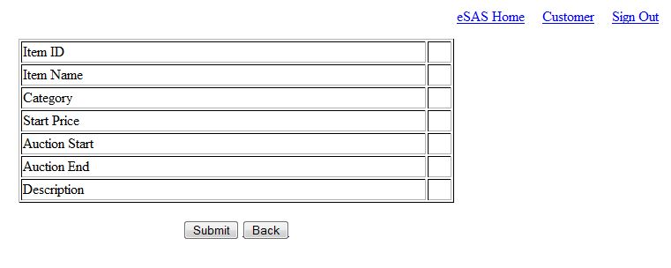

*Admin Management Page:*  
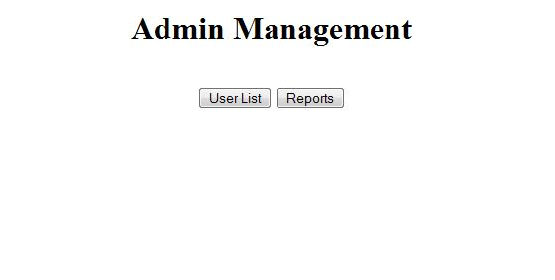

*Bid Management:*  
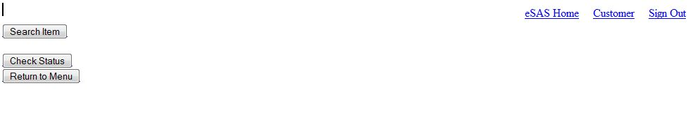

*Bid on Item:*  
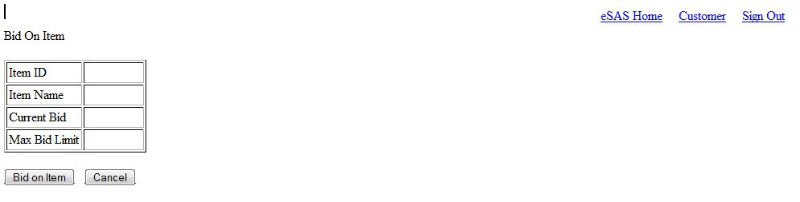

*Bidder List:*  
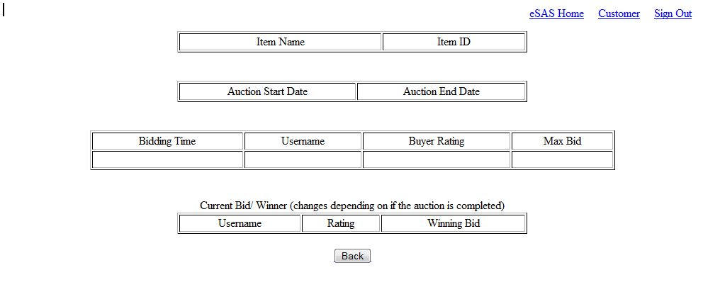

*Check Status:*  
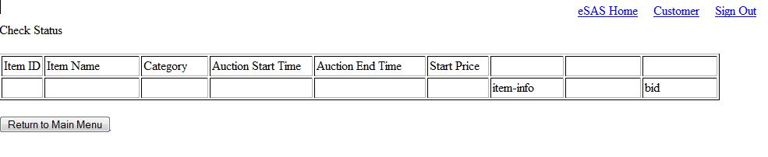

*Feedback:*  
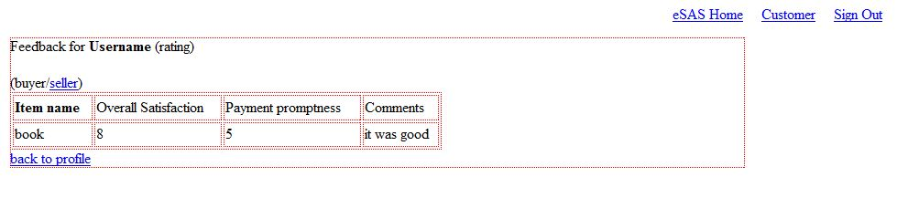

*Item Info:*  
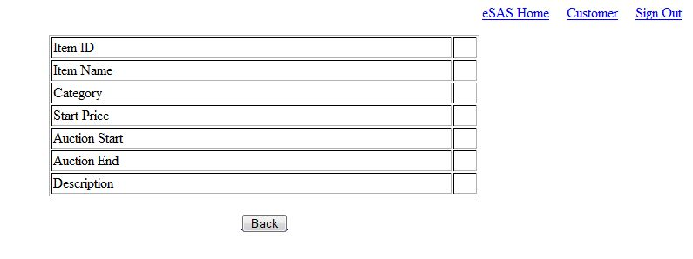

*Item Profile:*  
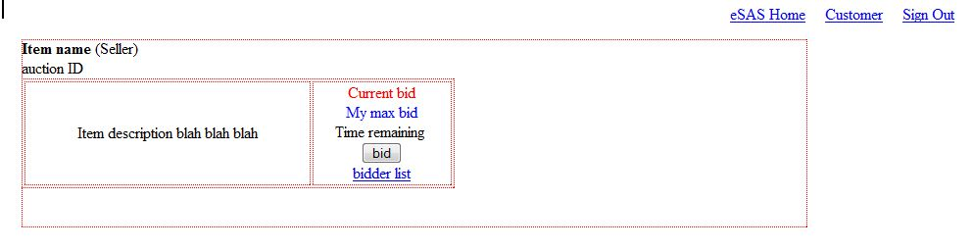

*Item Search:*  
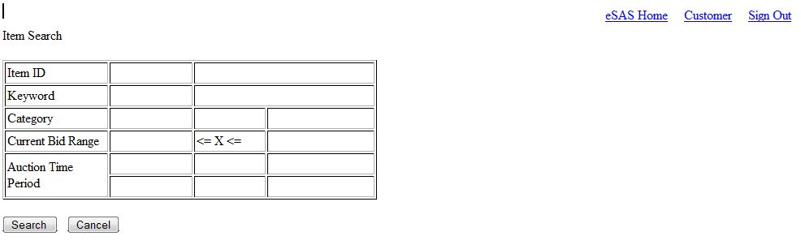

*List Items Sold:*  
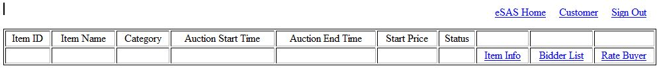

*List Items Bid On:*  
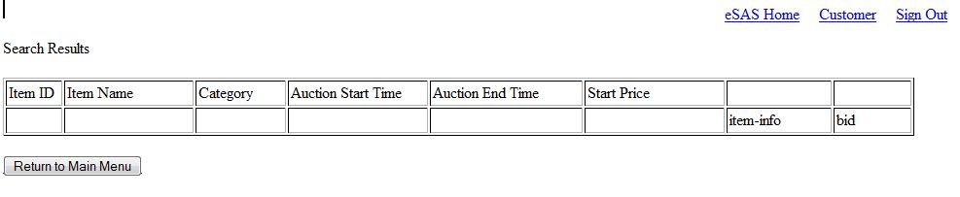

*Login Page:*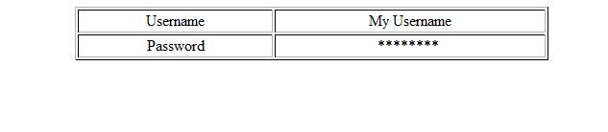

*Overall Commission Report:*  
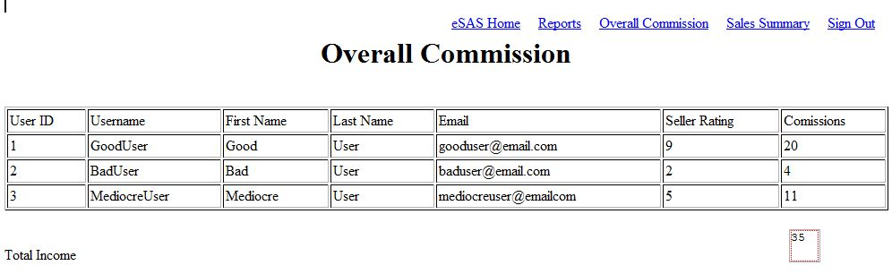

*Profile Page:*  
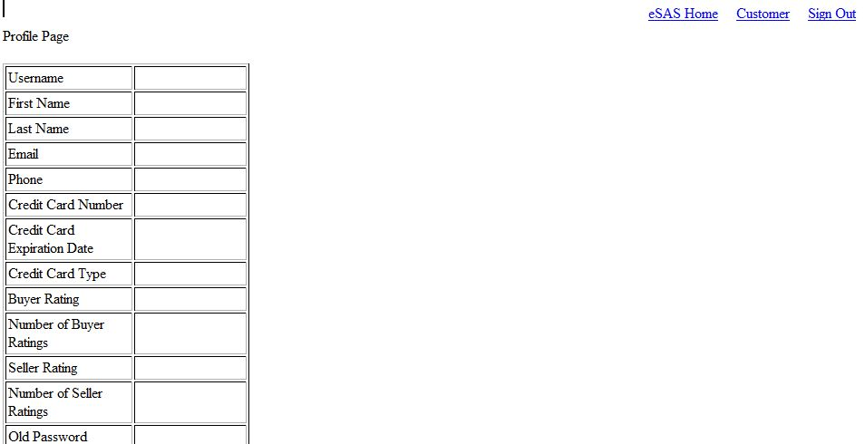

*Profile:*  
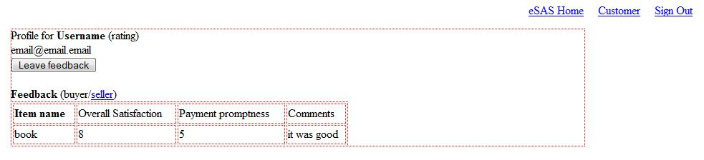

*Rate as Buyer:*  
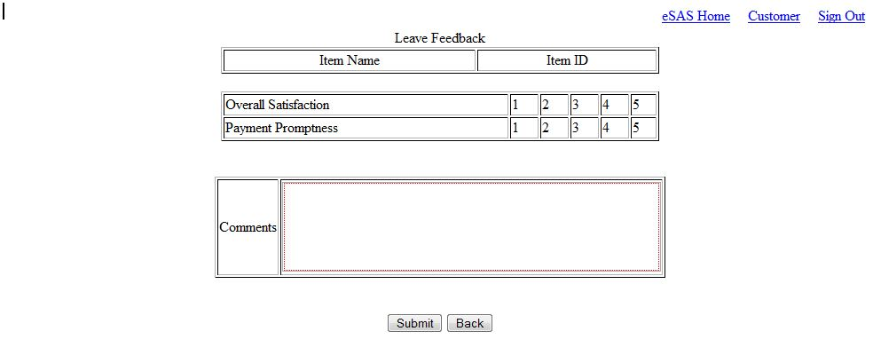

*Reports:*  
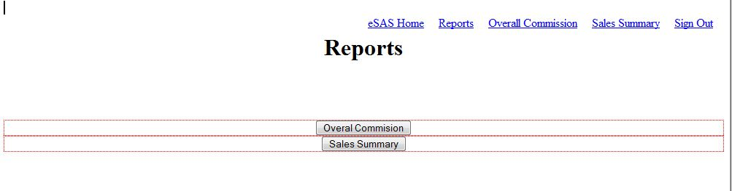

*Sales Summary Report:*  
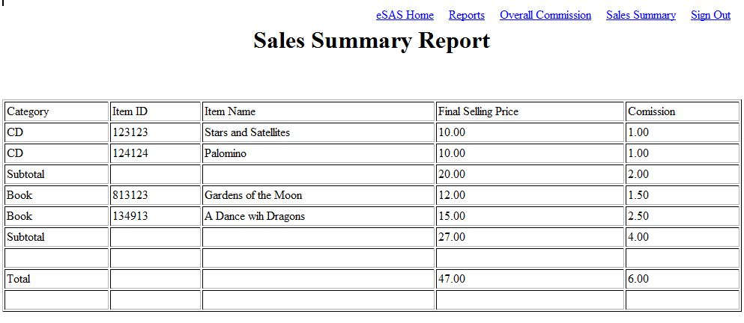

*Search Results:*  
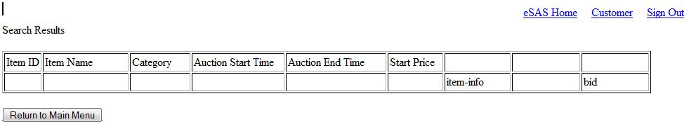

*Selling Management Page:*  
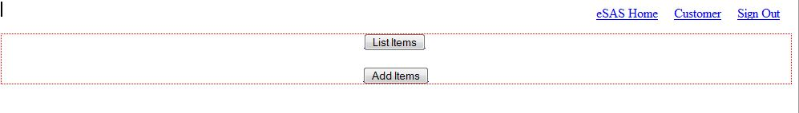

*Update Profile:*  
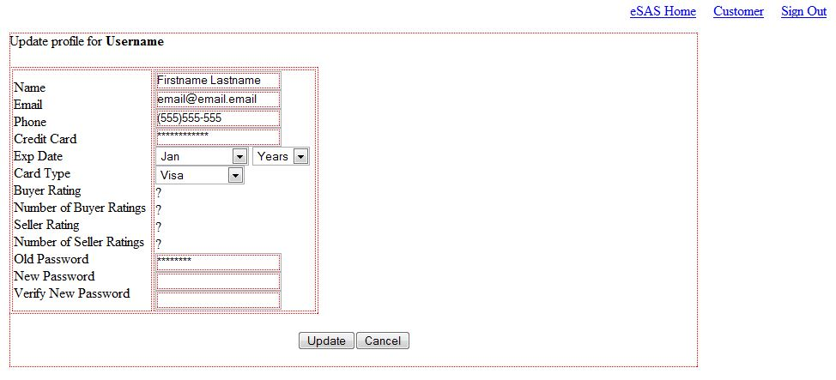

*User List:*  
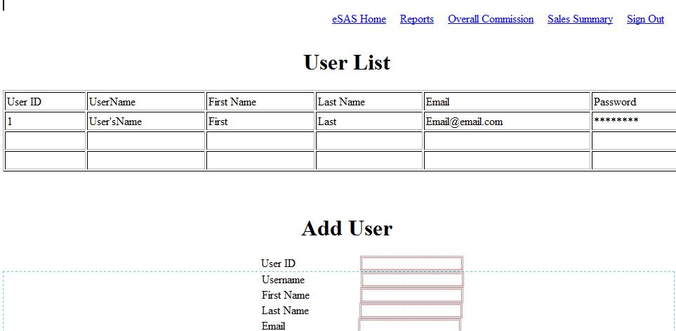

**Problems with System Description**

*Problems:*  
Is there a specific layout for what the “Check Status” page should look like?

*Additional Changes:*  
Created View Profile.

**Task Decomposition**

Justin – Visio/Word Map Diagram, UI: Login, Selling Management, List Items Sold, Add Items, Item Info, Bidder List, Rate Buyer (Rate Page) List of Items Sold (List Items Sold)

Katherine – UI: Header, Customer Management Page, View Profile, My Buyer Feedback, My Seller Feedback, Update Profile, Leave Feedback (Rate Page), List of Items Bought (List Item Sold), Rate Seller (Rate Page), Item Profile

Philip – UI: Admin Management Page, User List, Reports, Overall Commission, Sales Summary

Tsuehue – Meeting Minutes, Report, UI: Bidding Management, Search Item, Results, Bid On Item, Profile Page, Check Status, List of Items Bid On

**Meeting Minutes**

**Meeting 1 (10:30am – 11:40am)**  
  
**Attendance:**Justin Springer (here)

Katherine Kutzke (here)

Philip Nowak (here)

Tsuehue Xiong (here)

**Team Name:**

Rahal Rampager  
  
**Team Members:**

Justin Springer

Katherine Kutzke

Philip Nowak

Tsuehue Xiong

**Establish Meeting Time:**

Meeting time: (Starts Sept. 4)

Sunday (10:30pm – 12:30pm)

Wednesday (5:00pm – 7:00pm)

Friday (5:00pm – 7:00pm)

Location: Pengle Lab

**Past Experiences:**

Justin Springer – Spring, Hibernate, HTML

Katherine Kutzke – HTML, CSS

Philip Nowak - HTML

Tsuehue Xiong - HTML

**Next Meeting:**2nd meeting: 11:45am (Sept. 2) Pengle Lab

**Pages:**

Login Screen

-

Admin Management Page

-

User Management – (User List)

Admin Reports – (Overall Commission Report, Sales Summary Report)

Login

-

Customer Management Page

-

View Profile - (My Seller Feedback, My Buyer Feedback, Update Profile)

Selling Management – List Items Sold (Item Info, Bidder List, Rate Buyer), Add Items

Bidding Management – (Search Item [Search Results {Bid On Item <Profile Page>}], Check Status [List of Items Bid On])

Leave Feedback (Rate as Seller [List of Items Sold], Rate as Buyer [List of Items Bought {Rate Seller, Item Info}])

**Notes:**

-Created View Profile.  
-Move My Seller Feedback and My Buyer Feedback to View Profile.  
-Is there a specific layout the “Check Status” page should look like?

**HW (Due MONDAY):**

Justin – Visio/Word Map Diagram, UI: Selling Management, List Items Sold, Item Info, Bidder List, Rate Buyer, Rate as Seller, List of Items Sold

Katherine – UI: Customer Management Page, View Profile, My Buyer Feedback, My Seller Feedback, Update Profile, Leave Feedback, Rate as Buyer, List of Items Bought, Rate Seller, Item Info

Philip – UI: Admin Management Page, User Management, User List, Reports, Overall Commission, Sales Summary

Tsuehue – Meeting Minutes, UI: Bidding Management, Search Item, Results, Bid On Item, Profile Page, Check Status, List of Items Bid On  
  
**Summary:**  
-Went over requirements for Phase 1

**Meeting 2 (11:45am - 12:40pm)**  
**Attendance:**Justin Springer (here)

Katherine Kutzke (here)

Philip Nowak (here)

Tsuehue Xiong (absent, had class)

**Summary:**  
-Everyone checkup on UI status and Web Diagram Status  
-Discuss that we need to work on Web Diagram as a group because we had unnecessary pages  
-Work on UI.

**Meeting 3 (5:00pm – 6:00pm)**  
**Attendance:**Justin Springer (here)  
Katherine Kutzke (here)  
Philip Nowak (here)  
Tsuehue Xiong (here)  
  
**Notes:**  
-Clarify if the user can view other customer’s auctioned items.  
  
**Summary:**  
-Recap what is due for Phase 1.  
-Work on Web Diagram.  
-Work and finish UI.  
-Katie sent the UI Diagram Header.  
-Finish UI and Web Diagram send it to Tsuehue by 10:00pm to create the report.  
-Will decide if we need to meet after next class or at the beginning of the next phase.  
-Tsuehue will create the report  
-updated WHO-DID-WHAT